Get Started With Digital Security at CryptoParty PHX!

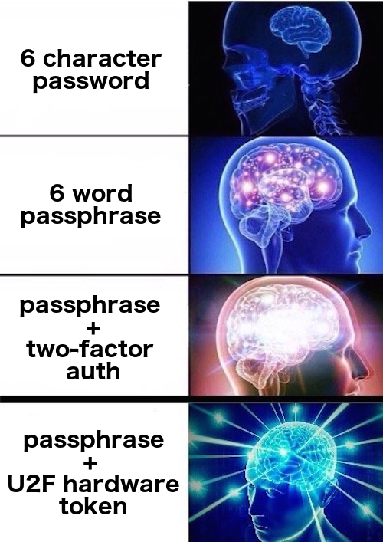
Are you a journalist, activist or anyone that wants to protect their email, personal information and other stuff too? Stop by CryptoParty to learn how!
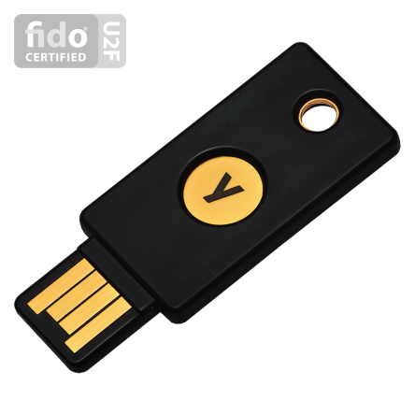

FREE YUBIKEY FOR FIRST 10 ATTENDEES
😎😎😎😎😎😎😎😎😎😎
(Normally $40 each)

CryptoParty Phoenix
***Sunday, Oct 1st, 2017***
3PM – 5PM

@ Megaphone PHX
4700 N. Central Ave. Suite 112
Phoenix, AZ

Follow us on Twitter: @cryptopartyphx
Find CryptoParty in other cities you hang out in: https://cryptoparty.in

